RS.con Event tracking – Phase 1 Specifications

Our Analytics Department wants to begin to use Google analytics to track different user actions. There are a couple of ways that we can do this: the first is to add various onclick attributes to anchor tags. the second way is to add DOM listeners to onClick events in an external javascript file. The first way is simpler to implement but will increase page weight and be more difficult to maintain. The second way will easier to maintain, more extensible, and shouldn’t significantly increase page weight but may take longer to implement.

Method 1 example:

From <a href="/movies">Movies</a>
To <a href="/movies" onclick="_gaq.push(‘_trackEvent’,’category’,‘action’,‘opt_label’);">Movies</a>

onclick="_gaq.push(‘_trackEvent’,Social,‘Facebook,‘ /movies/photos/behind-the-scenes-with-jon-stewart-20110914/0196995);"

Method 2 conceptual example:

In html
From <div class=”header”><a href="/movies">Movies</a>…</div>
To <div class=”header”><a href="/movies" id=”navMovies”>Movies</a>

In external js (untested code)
$(document).ready(function() {
var nav_mov = $(“#navMovies”);
nav_mov.onclick = funtion(){
_gaq.push(['_trackEvent', 'Nav', 'Topnav', 'Movies']);
}
}

The first areas of the site that event tracking should be added to are the top navigation bar, subscription links, and commenting.

Category | Action | Label
Nav | Topnav | Music
 |  | Politics
 |  | Movies
 |  | Reviews/Album
 |  | Reviews/Songs
 |  | Reviews/Movies
 |  | Artists
 |  | Blogs/Taibbi
 |  | Blogs/Travers
 |  | Blogs/Fricke
 |  | Blogs/Sheffield
 |  | Blogs/DailyPol
 |  | Blogs/Tech
 |  | Blogs/Fashion
 |  | Blogs/Editors
 |  | Blogs/Others
 |  | Photos
 |  | Videos
Subs | Newsletter | URL Source
 | Magazine | Top
 |  | Footer
 |  | Gift
 |  | Back Issues
 |  | All Access
 |  | Covers
Social | Comment | URL Source

The following diagrams illustrate the _trackevent() parameter values that should be included in each onclick event (whether it be via method 1 or 2.

Top navigation bar:
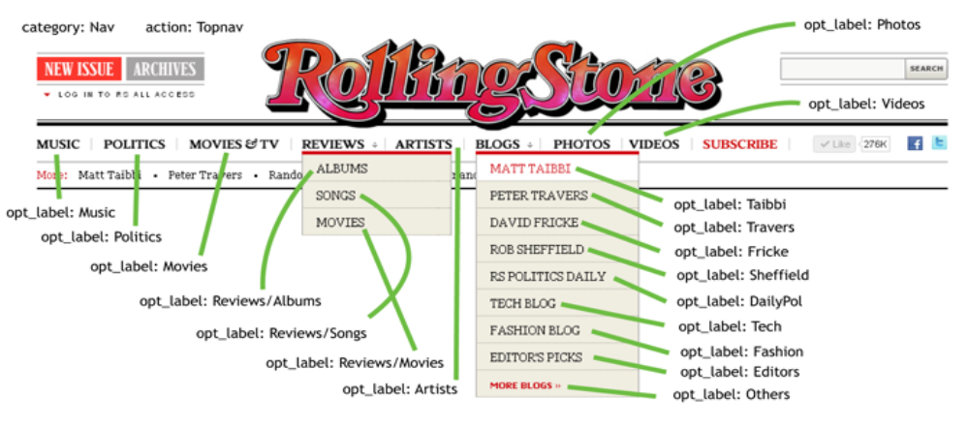
subscription links: Category: Subs

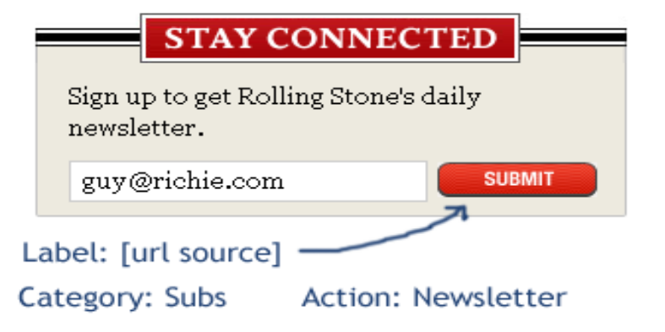 | 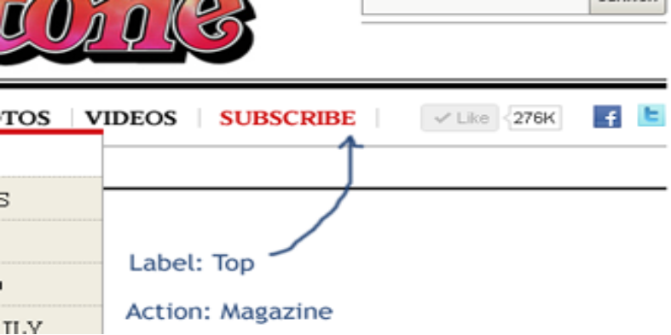

subscription links (cont)

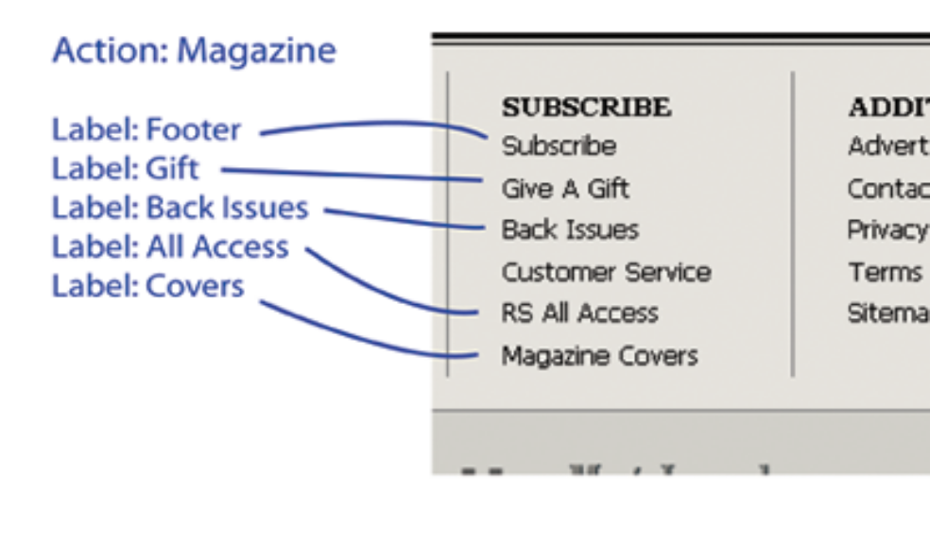
Commenting:



